1.5 Inverse of a Matrix
Definition: If A is a square matrix, and if a matrix B of the same size can be found such that
$$AB=BA=I (Identity Matrix)$$
then A is said to be invertible (or nonsingular) and B is called an inverse of A. If no such matrix B can be found, then A is said to be singular.
The relationship $AB=BA=I$ is not changed by interchanging A and B, so if A is invertible and B is an inverse of A, then it is also true that B is invertible, and A is an inverse of B. Thus, when $AB=BA=I$ ,we say that A and B are inverses of one another.
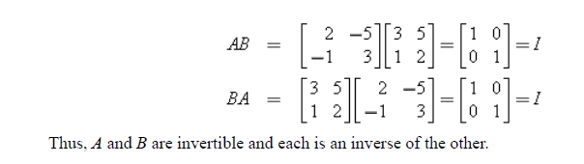
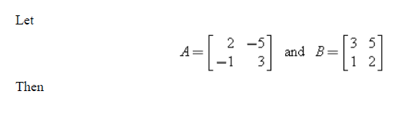
Remarks:
- In general, a square matrix with a row or column of zeros is singular.
- An invertible matrix has exactly one inverse.
Formula for the Inverse of a matrix:
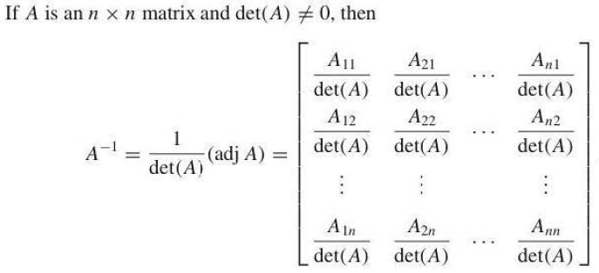
For a 2x2 matrix this formula is easy to use. For example 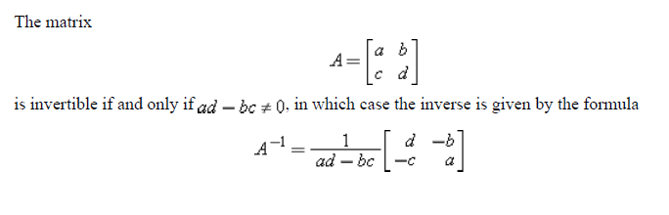
Example 1:
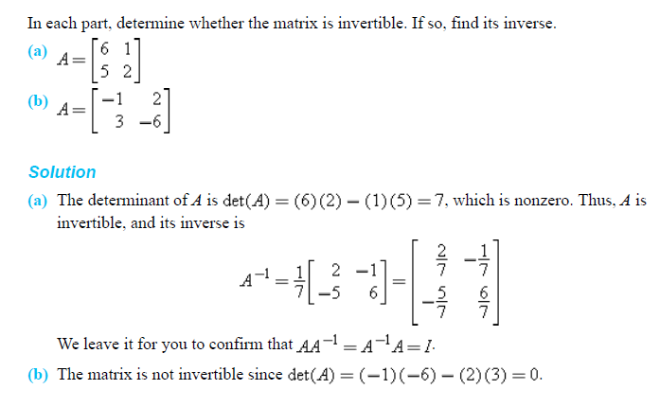
Example 2:
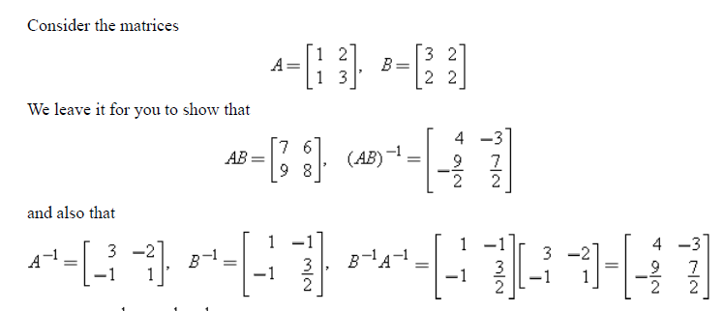
Remark:
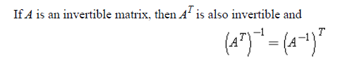
For a matrix of order higher than 2x2 we use the inversion algorithm to find its inverse (based on steps used for the reduced row echelon form).
1.5 Inversion Algorithm
To find the inverse of an invertible matrix A, find a sequence of elementary row operations that reduces A to the identity and then perform that same sequence of operations on $I_{n}$to obtain $A^{-1}$.
Example 4:
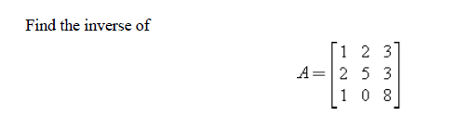
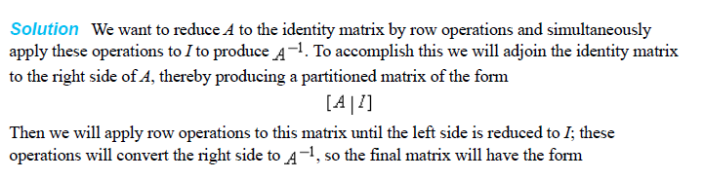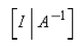
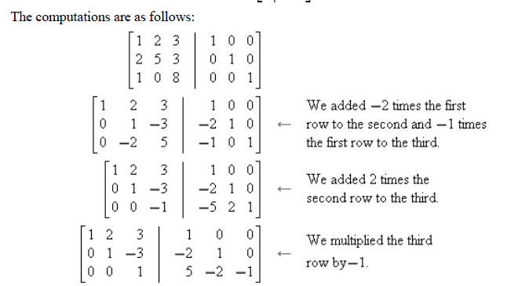
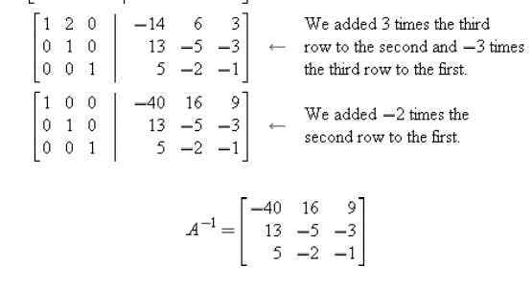
Example 5:
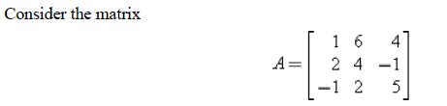
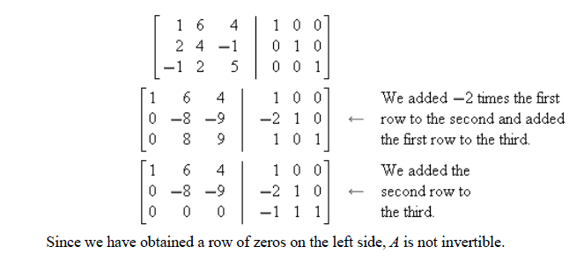
Work to do
Q1. Determine whether the statement is true or false, and justify your answer.
- For all square matrices A and B of the same size
${(A+B)}^{2}=A^{2}+2AB+B^{2}.$
(ii) The product of two elementary matrices of the same size must be an elementary matrix.
(iii) If A is an $n×n$ matrix that is not invertible, then the linear system $Ax=0$ has infinitely many solutions.
(iv) It is impossible for a linear system of linear equations to have exactly two solutions.
(v) If A and B are invertible matrices of the same size, then AB is invertible and ${(AB)}^{-1}=A^{-1}B^{-1}.$
(vi) Every elementary matrix is invertible.
(vii) If A is invertible and a multiple of the first row of A is added to the second row, then the resulting matrix is invertible.
(viii) If the linear system$Ax=b$ has a unique solution, then the linear system$Ax=c$ also must have a unique solution.
Q2. Use the inversion algorithm to find the inverses of the given matrices, if exist.
- $\left[\begin{aligned}1 2 -3 \\ 1 -2 1 \\ 5 -2 -3\end{aligned}\right] \left(ii\right) \left[\begin{aligned}0 2 3 \\ 1 1 1 \\ 5 5 1\end{aligned}\right]$
(iii) $\left[\begin{aligned}2 6 6 \\ 2 7 6 \\ 2 7 7\end{aligned}\right] , \left(iv\right) \left[\begin{aligned}-1 3 -4 \\ 2 4 1 \\ -4 2 -9\end{aligned}\right]$ , $(v) \left[\begin{aligned} 2 5 5 \\ -1 -1 0 \\ 2 4 3\end{aligned}\right]$
Q3. Find all values of c, if any, for which the given matrix is invertible.
- $\left[\begin{aligned}c c 1 \\ 1 1 c \\ 0 1 c\end{aligned}\right]$
- $\left[\begin{aligned}c c -1 \\ 1 1 2c \\ 0 1 c\end{aligned}\right]$
- $\left[\begin{aligned}c c c \\ 1 c c \\ 1 1 c\end{aligned}\right]$
Q4. Find det A and det B using row or column of your choice and using reduced matrix.
$$A=\left[\begin{aligned}-3 0 7 \\ 2 5 1 \\ -1 0 5\end{aligned}\right], B=\left[\begin{aligned}3 3 0 5 \\ 2 2 0 -2 \\ 4 1 -3 0 \\ 2 10 3 2\end{aligned}\right]$$
Q5. If $\left|\begin{aligned}a b c \\ d e f \\ g h i\end{aligned}\right|=-6$, then $\left|\begin{aligned}3a 3b 3c \\ -d -e -f \\ 4g 4h 4i\end{aligned}\right|=?$

